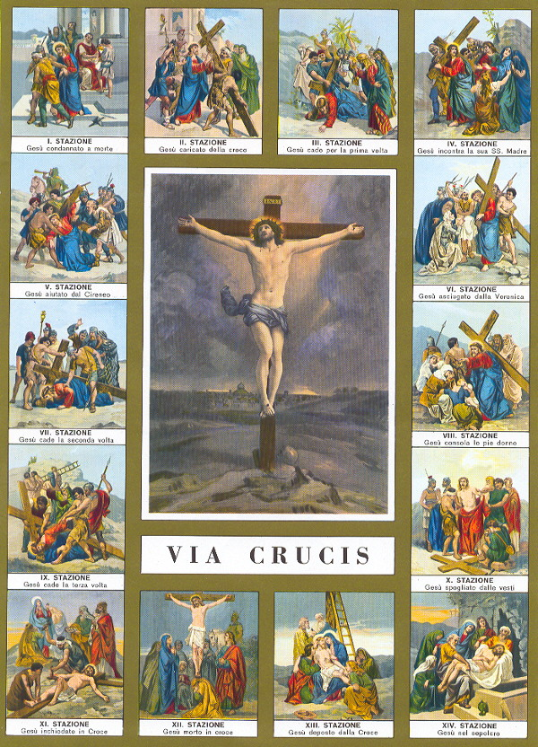

Preparatory Prayer
Most merciful Lord, * with a contrite heart and penitent spirit * I bow down before Thy divine Majesty. * I adore Thee as my supreme Lord and Master. * I believe in Thee, * I hope in Thee, * I love Thee above all things. * I am heartily sorry for having offended Thee, * my only and supreme God. * I firmly resolve to amend my life; * and although I am unworthy to obtain mercy, * yet looking upon Thy holy Cross * I am filled with peace and consolation. * I will, therefore, meditate on Thy sufferings, * and visit the Stations * in company with Thy sorrowful Mother * and my holy Guardian Angel, * to promote Thy honor and to save my soul. *
I desire to gain all indulgences granted to this holy exercise * for myself and for the souls in Purgatory. *
O Loving Jesus, * inflame my cold heart with Thy love, * that I may perform this devotion as perfectly as possible, * and that I may live and die in union with Thee. Amen.
Stabat Mater Stanza:
Stabat Mater dolorosa (At the cross her station keeping)
Juxta crucem lacrymosa (Stood the mournful Mother weeping)
Dum pendebat Filius (Close to Jesus to the last)

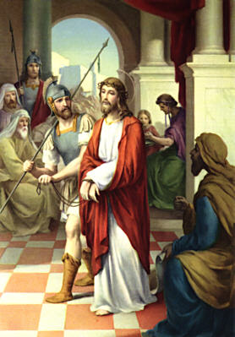 |  | First Station - Jesus Is Condemned to Death  V. We adore Thee, O Christ, and we praise Thee.  R. Because by Thy holy Cross, Thou hast redeemed the world.  From the Gospel according to Matthew 27:22-23,26  Pilate said to them, “Then what should I do with Jesus who is called the Messiah?” All of them said, “Let him be crucified!” Then he asked, “Why, what evil has he done?” But they shouted all the more, “Let him be crucified!” So he released Barabbas for them; and after flogging Jesus, he handed him over to be crucified  Jesus, the most innocent of beings, is condemned to death, yes, to the shameful death of the cross. In order to remain a friend of Caesar, Pilate delivers Jesus into the hands of His enemies. O fearful crime, to condemn Innocence to death and to displease God in order to please men.  O innocent Jesus, * I have sinned and I am guilty of eternal death; * but that I may Live, * Thou dost gladly accept the unjust sentence of death. * For whom then shall I henceforth live * if not for Thee, my Lord? * If I desire to please men, * I can not be Thy servant. * Let me, therefore, rather displease the whole world * than not please Thee, O Jesus!  Our Father, Hail Mary, Glory be.  V. Lord Jesus, crucified.  R. Have mercy on us.  Through her heart, His sorrow sharing,  All His bitter anguish bearing,  Now at length the sword had passed.
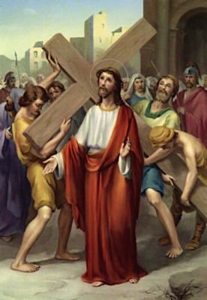 |  | Second Station - Jesus Carries His Cross  V. We adore Thee, O Christ, and we praise Thee.  R. Because by Thy holy Cross, Thou hast redeemed the world.  From the Gospel according to Matthew. 27:27-31  Then the soldiers of the governor took Jesus into the governor’s headquarters, and they gathered the whole cohort around him. They stripped him and put a scarlet robe on him, and after twisting some thorns into a crown, they put it on his head. They put a reed in his right hand and knelt before him and mocked him, saying, “Hail, King of the Jews!” They spat on him, and took the reed and struck him on the head. After mocking him, they stripped him of the robe and put his own clothes on him. Then they led him away to crucify him.  When our divine Redeemer beheld the Cross, He most willingly reached out to it with His bleeding arms. He embraced it lovingly, kissed it tenderly, took it on His bruised shoulders, and, exhausted as He was, He carried it joyfully.  O my Jesus, * I cannot be Thy friend and follower * if I refuse to carry my cross. * O beloved cross, * I embrace Thee, * I kiss Thee, * I joyfully accept Thee from the hand of my God. * Far be it from me to glory in anything * save in the Cross of my Lord and Redeemer. * By it the world shall be crucified to me, * and I to the world, * that I may be Thine forever.  Our Father, Hail Mary, Glory be.  V. Lord Jesus, crucified.  R. Have mercy on us.  O, how sad and sore distressed  Was that Mother, highly blest,  Of the sole begotten One!
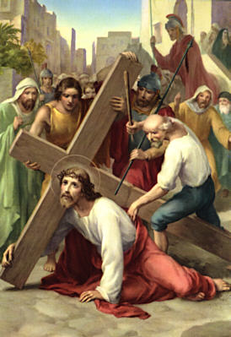 |  | Third Station - Jesus Falls the First Time  V. We adore Thee, O Christ, and we praise Thee.  R. Because by Thy holy Cross, Thou hast redeemed the world.  From the Book of the Prophet Isaiah. 53:4-6  Surely he has born our griefs and carried our sorrows; yet we esteemed him stricken, smitten by God, and afflicted. But he was wounded for our transgressions, he was bruised for our iniquities; upon him was the chastisement that made us whole, and with his stripes we are healed. All we like sheep have gone astray; we have turned everyone to his own way; and the Lord has laid on him the iniquity of us all.  Carrying the Cross, our dear Saviour was so weakened with its heavy weight that He fell exhausted to the ground. The Cross was light and sweet to Him, but our sins made it so heavy and hard to carry.  Beloved Jesus, * Thou didst carry the burden and the heavy weight of my sins. * Should I then not bear in union with Thee * my light burden of suffering, * and accept the sweet yoke of Thy commandments? * Thy yoke is sweet and Thy burden is light. * I willingly accept it. * I will take up my cross and follow Thee.  Our Father, Hail Mary, Glory be.  V. Lord Jesus, crucified.  R. Have mercy on us.  Christ above in torment hangs:  She beneath beholds the pangs  Of her dying glorious Son.
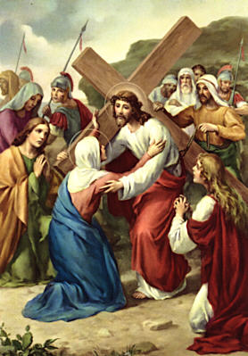 |  | Fourth Station - Jesus Meets His Blessed Mother  V. We adore Thee, O Christ, and we praise Thee.  R. Because by Thy holy Cross, Thou hast redeemed the world.  From the Gospel according to Luke. 2:34-35,51  Simon blessed them and said to Mary his mother: “Behold, this child is set for the fall and rising of many in Israel, and for a sign that is spoken against (and a sword will pierce through your own soul also), that thoughts out of many hearts may be revealed”. And his mother kept all these things in her heart.  How sad and how painful must it have been for Mary to behold her beloved Son laden with the Cross, covered with wounds and blood, and driven through the streets by savage executioners! What unspeakable pangs her most tender heart must have experienced! How earnestly did she desire to die instead of Jesus, or at least with Him!  O Jesus, * O Mary, * I am the cause of the pains that pierced your hearts. * Would that my heart might experience some of your sufferings. * O Mother, * let me share in thy sufferings and those of they Son, * that I may obtain the grace of a happy death.  Our Father, Hail Mary, Glory be.  V. Lord Jesus, crucified.  R. Have mercy on us.  Is there one who would not weep,  Whelmed in miseries so deep,  Christ’s dear Mother to behold?
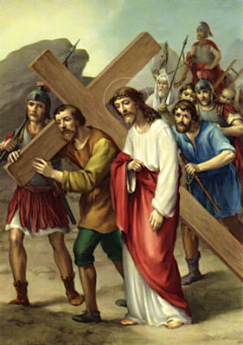 |  | Fifth Station - Simon of Cyrene Helps Jesus Carry His Cross  V. We adore Thee, O Christ, and we praise Thee.  R. Because by Thy holy Cross, Thou hast redeemed the world.  From the Gospel according to Matthew. 27:32; 16:24  As they went out, they came upon a man of Cyrene, Simon by name; this man they compelled to carry his cross. Jesus told his disciples, “If any man would come after me, let him deny himself and take up his cross and follow me.  Simon of Cyrene was forced to help our exhausted Saviour carry His Cross. How pleased would Jesus have been, had Simon offered his services of his own accord. However, Simon was not invited by Christ as you are. He says: "Take up your cross and follow Me." Nevertheless you recoil, and carry it grudgingly.  O Jesus, * whosoever does not take up his cross and follow Thee, * is not worthy of Thee. * Behold, I cheerfully join Thee on the way of the cross. * I desire to carry it with all patience until death, * that I may prove worthy of Thee.  Our Father, Hail Mary, Glory be.  V. Lord Jesus, crucified.  R. Have mercy on us.  Can the human heart refrain  From partaking in her pain,  In that Mother’s pain untold?
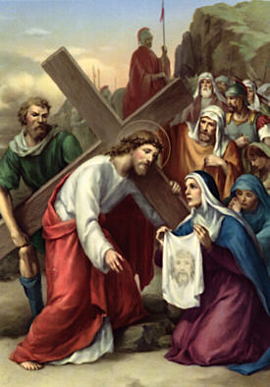 |  | Sixth Station - Veronica Wipes the Face of Jesus  V. We adore Thee, O Christ, and we praise Thee.  R. Because by Thy holy Cross, Thou hast redeemed the world.  From the Book of the Prophet Isaiah. 53:2-3  He had no form or comeliness that we should look at him, and no beauty that we should desire him. He was despised and rejected by men; a man of sorrows, and acquainted with grief; and as one from whom men hide their faces he was despised, and we esteemed him not.  From the Book of Psalms. 27:8-9  You have said, “Seek my face”. My heart says to you, “Your face, Lord, do I seek”. Hide not your face from me. Turn not your servant away in anger, you who have been my help. Cast me not off, forsake me not, O God of my salvation.  Moved by compassion, Veronica presents her veil to Jesus, to wipe His disfigured face. He imprints on it His holy countenance, and returns it to her as a recompense. Shall Christ reward you in like manner? Then you too must do Him a service. But you do a service to Christ every time you perform a work of mercy towards your neighbor: for He says: "What you have done to the least of My brethren, you have done to Me."  Dearest Jesus, * what return shall I make Thee for all Thy benefits? * Behold, I consecrate myself entirely to Thy service. * My whole heart I give to Thee; * stamp on it Thy holy image, * that I may never forget Thee.  Our Father, Hail Mary, Glory be.  V. Lord Jesus, crucified.  R. Have mercy on us.  Bruised, derided, cursed, defiled,  She beheld her tender Child,  All with bloody scourges rent.
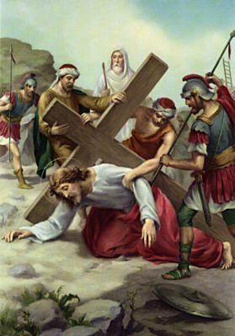 |  | Seventh Station - Jesus Falls the Second Time  V. We adore Thee, O Christ, and we praise Thee.  R. Because by Thy holy Cross, Thou hast redeemed the world.  From the Book of Lamentations. 3:1-2,9,16  I am the man who has seen affliction under the rod of his wrath; he has driven and brought me into darkness without any light. He has blocked my way with hewn stones, he has made my paths crooked. He has made my teeth grind on gravel, and made me cower in ashes.  Overwhelmed by the weight of the Cross, Jesus falls again to the ground. But the cruel executioners do not permit Him to rest a moment. With thrusts and blows they urge Him onward. With what cruelty Jesus in treated and trampled under foot! Remember, compassionate soul, that your sins caused Jesus this painful fall.  Have mercy on me, O Jesus, * and help me never to fall into my former sins. * From this moment I will strive sincerely * never to sin again. * But Thou, O Jesus, strengthen me with Thy grace, * that I may faithfully carry out my resolution.  Our Father, Hail Mary, Glory be.  V. Lord Jesus, crucified.  R. Have mercy on us.  For the sins of His own nation,  Saw Him hang in desolation  Till His spirit forth He sent.
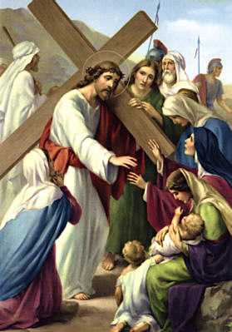 |  | Eighth Station - Jesus Speaks to the Women of Jerusalem  V. We adore Thee, O Christ, and we praise Thee.  R. Because by Thy holy Cross, Thou hast redeemed the world.  From the Gospel according to Luke. 23:28-31  Jesus turning to them said, “Daughters of Jerusalem, do not weep for me, but weep for yourselves and for your children. For behold, the days are coming when they will say, ‘Blessed are the barren, and the wombs that never bore, and the breasts that never gave suck!’ Then they will begin to say to the mountains, ‘Fall on us’; and to the hills, ‘Cover us’. For if they do this when the wood is green, what will happen when it is dry?”  Moved by compassion, these devoted women weep over our suffering Savior. But He turns to them and says: "Weep not for Me, but weep for yourselves and your children. Weep for your sins and those of your children; for they are the cause of My suffering." You also must weep over your sins, for there is nothing more pleasing to our Lord and more useful to yourself than the tears you shed out of contrition for your sins.  O Jesus, * who shall give my eyes a torrent of tears, * that I may day and night weep over my sins? * I beseech Thee by Thy bitter and bloody tears * to move my heart, * so that tears may flow in abundance from my eyes, * and that I may weep over Thy sufferings * and over my sins until death.  Our Father, Hail Mary, Glory be.  V. Lord Jesus, crucified.  R. Have mercy on us.  O thou Mother: font of love!  Touch my spirit from above,  Make my heart with thine accord.
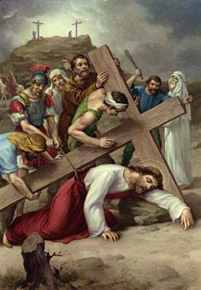 |  | Ninth Station - Jesus Falls the Third Time  V. We adore Thee, O Christ, and we praise Thee.  R. Because by Thy holy Cross, Thou hast redeemed the world.  From the Book of Lamentations. 3:27-32  It is good for a man that he bear the yoke in his youth. Let him sit alone in silence when he has laid it on him; let him put his mouth in the dust - there may yet be hope; let him give his cheek to the smiter, and be filled with insults. For the Lord will not cast off for ever, but, though he cause grief, he will have compassion, according to the abundance of his steadfast love.  Exhausted at the foot of Calvary, Jesus falls for the third time to the ground. How painfully must have been reopened all the wounds of His tender body by these repeated falls. And how enormous must my sins be, to cause Jesus to fall so painfully. Had not Jesus taken my sins upon Himself, they would have plunged me into the abyss of Hell.  Most merciful Jesus, * I return Thee a thousand thanks * for not permitting me to die in my sins * and fall into the abyss of Hell, * as I have deserved so often. * Enkindle in me a sincere desire to amend my life. * Let me never again fall into sin, * but grant me the grace of final perseverance.  Our Father, Hail Mary, Glory be.  V. Lord Jesus, crucified.  R. Have mercy on us.  Make me feel as thou has felt;  Make my soul to glow and melt,  With the love of Christ my Lord.
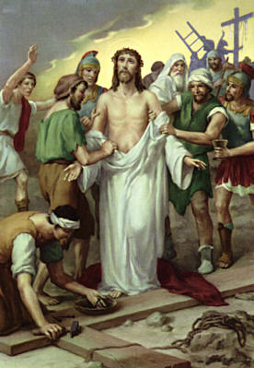 |  | Tenth Station - Jesus Is Stripped of His Garments  V. We adore Thee, O Christ, and we praise Thee.  R. Because by Thy holy Cross, Thou hast redeemed the world.  From the Gospel according to Matthew. 27:33-36  And when they came to a place called Golgotha (which means the place of a skull), they offered him wine to drink, mingled with gall, but when he tasted it, he would not drink it. And when they had crucified him, they divided his garments among them by casting lots; then they sat down and kept watch over him there.  Arriving on Calvary, Jesus was cruelly deprived of His garments. How painful the stripping must have been, because the garments adhered to His mangled body, so that in removing them parts of the flesh were torn away. Jesus is deprived of His garments that He may die possessed of nothing. How happy shall not I die after laying aside my evil habits and tendencies!  Help me, O Jesus, to amend my life. * Let it be renewed according to Thy will and desire. * However painful the correction may be to me, * I will not spare myself. * With the assistance of Thy grace, * I will refrain from all sinful pleasure and vain amusement, * that I may die happy and live forever.  Our Father, Hail Mary, Glory be.  V. Lord Jesus, crucified.  R. Have mercy on us.  Holy Mother, pierce me through;  In my heart each wound renew  Of my Savior crucified.
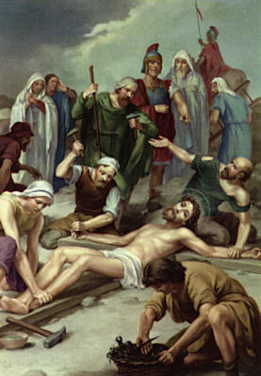 |  | Eleventh Station - Jesus Is Nailed to the Cross  V. We adore Thee, O Christ, and we praise Thee.  R. Because by Thy holy Cross, Thou hast redeemed the world.  From the Gospel according to Matthew 27:37-42  And over his head they put the charge against him, which read, “This is Jesus the King of the Jews”. Then two robbers were crucified with him, one on the right hand and one on the left. And those who passed by derided him, wagging their heads and saying, “You who would destroy the temple and build it in three days, save yourself! If you are the Son of God, come down from the Cross”. So also the chief priests with the scribes and elders mocked him, saying, “He saved others; he cannot save himself. He is the King of Israel; let him come down now from the Cross and we will believe in him”.  Stripped of His garments, Jesus is violently thrown down on the Cross. His hands and His feet are nailed to it in the most cruel way. Jesus remains silent, because it so pleases His heavenly Father. He suffers patiently, because He suffers for you. How do you act in sufferings and trials? How fretful and impatient, how full of complaints are you!  O Jesus, * meek and patient Lamb, * I renounce forever my impatience. * Crucify, O Lord, my flesh, * with its evil desires and vices. * Punish and afflict me in this life, * but spare me in the next. * I resign myself altogether to Thy holy will. * May it be done in all things.  Our Father, Hail Mary, Glory be.  V. Lord Jesus, crucified.  R. Have mercy on us.  Let me share with Thee His pain,  Who for all my sins was slain,  Who for me in torment died.
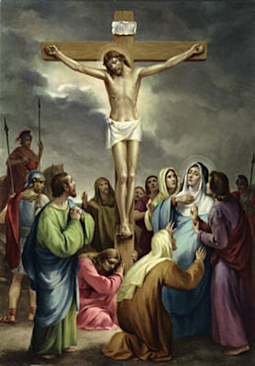 |  | Twelfth Station - Jesus Dies on the Cross  V. We adore Thee, O Christ, and we praise Thee.  R. Because by Thy holy Cross, Thou hast redeemed the world.  From the Gospel according to John 19:19-20  Pilate also wrote a title and put it on the Cross; it read, “Jesus of Nazareth, the King of the Jews”. Many of the Jews read this title, for the place where Jesus was crucified was near the city; and it was written in Hebrew, in Latin, and in Greek.  From the Gospel according to Matthew 27:45-50,54  Now from the sixth hour there was darkness over all the land until the ninth hour. And about the ninth hour Jesus cried with a loud voice, “Eli, Eli, lama sabachthani?” That is, “My God, my God, why have you forsaken me?” And some of the bystanders hearing it said, “This man is calling Elijah”. And one of them at once ran and took a sponge, filled it with vinegar, and put it on a reed, and gave it to him to drink. But the others said, “Wait, let us see whether Elijah will come to save him”. And Jesus cried again with a loud voice and yielded up his spirit”. When the centurion and those who were with him, keeping watch over Jesus, saw the earthquake and what took place, they were filled with awe, and said, “Truly this was the Son of God!”  Behold Jesus crucified! Behold His wounds received for love of you! His whole appearance betokens love. His head is bent to kiss you. His arms are extended to embrace you. His heart is open to receive you. Oh what love! Jesus dies on the Cross, to preserve you from eternal death.  Most lovable Jesus, * who will grant that I may die for love of Thee? * I will endeavour to die to the world and its vanities * when I behold Thee on the Cross * covered with wounds and crowned with thorns. * Merciful Jesus, * take me into Thy wounded heart, * that I may despise all perishable things, * to live and die for Thee alone.  Our Father, Hail Mary, Glory be.  V. Lord Jesus, crucified.  R. Have mercy on us.  Let me mingle tears with thee,  Mourning Him who mourned for me,  All the days that I may live.
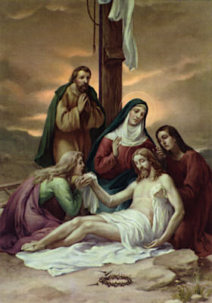 |  | Thirteenth Station - Jesus Is Taken Down From the Cross  V. We adore Thee, O Christ, and we praise Thee.  R. Because by Thy holy Cross, Thou hast redeemed the world.  From the Gospel according to Matthew 27:54-55  When the centurion and those who were with him, keeping watch over Jesus, saw the earthquake and what took place, they were filled with awe, and said, “Truly this was the Son of God!” There were also many women there, looking on from afar, who had followed Jesus from Galilee, ministering to him.  Jesus did not descend from the Cross, but remained on it till His death. When taken down, He rested on the bosom of His beloved Mother as He had so often done in life. Persevere in your good resolutions, and do not flee from the cross. For he who perseveres till the end shall be saved. Consider, moreover, how pure the heart should be that receives the body and blood of Jesus Christ in the adorable Sacrament of the Altar.  O Lord Jesus crucified! * I most earnestly entreat Thee: * Help me do what is right * and let me not be separated from Thy Cross, * for on it I desire to live and to die. * Create in me, O Lord, a clean heart, * that I may worthily receive Thee in Holy Communion, and that Thou mayest remain in me, * and I in Thee, * for all eternity.  Our Father, Hail Mary, Glory be.  V. Lord Jesus, crucified.  R. Have mercy on us.  By the cross with thee to stay;  There with thee to weep and pray  Is all I ask of thee to give.
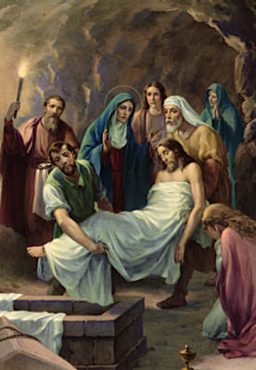 |  | Fourteenth Station - Jesus Is Laid in the Tomb  V. We adore Thee, O Christ, and we praise Thee.  R. Because by Thy holy Cross, Thou hast redeemed the world.  From the Gospel according to Matthew 27:59-61  Joseph took the body, and wrapped it in a clean linen shroud, and laid it in his own new tomb, which he had hewn in the rock; and he rolled a great stone to the door of the tomb, and departed. Mary Magdalene and the other Mary were there, sitting opposite the sepulchre.  The body of Jesus is laid in a stranger’s tomb. He Who in this world had not whereon to rest His head, would have no grave of His own after death. You whose heart is still attached to this world, despise it that you may not perish with it.  O Jesus, * Thou hast singled me out from the world, * what then shall I seek in it? * Thou hast created me for Heaven, * what then shall I desire upon earth? * Depart from me, deceitful world, with thy vanities! Henceforth I will walk the way of the Cross * traced out for me by my Redeemer, * and journey onward to my heavenly home, * where my rest and my joy shall be forever.  Our Father, Hail Mary, Glory be.  V. Lord Jesus, crucified.  R. Have mercy on us.  Virgin of all virgins best,  Listen to my fond request:  Let me share thy grief divine.

PRAYERS IN HONOR OF THE PASSION
O my Lord Jesus, in honor of Your Passion and death, I offer the following prayers:
Our Father, Who art in Heaven, hallowed be Thy Name. Thy Kingdom come, Thy will be done on earth, as it is in Heaven. And give us this day our daily bread and forgive us our trespasses as we forgive those who trespass against us. And lead us not into temptation, but deliver us from evil.
Hail Mary, full of grace, the Lord is with thee. Blessed art thou among women and blessed is the Fruit of thy womb, Jesus. Holy Mary, Mother of God, pray for us sinners, now and at the hour of our death.
Glory be to the Father, and to the Son, and to the Holy Spirit, as it was in the beginning, is now, and ever shall be, world without end. Amen.
PRAYERS FOR THE INTENTIONS OF THE HOLY FATHER
O, my lord Jesus, I offer the following prayers as my petition for this month's intentions of our holy father, the Pope:
Our Father, Who art in Heaven, hallowed be Thy Name. Thy Kingdom come, Thy will be done on earth, as it is in Heaven. And give us this day our daily bread and forgive us our trespasses as we forgive those who trespass against us. And lead us not into temptation, but deliver us from evil.
Hail Mary, full of grace, the Lord is with thee. Blessed art thou amongst women and blessed is the Fruit of thy womb, Jesus. Holy Mary, Mother of God, pray for us sinners, now and at the hour of our death.
Glory be to the Father, and to the Son, and to the Holy Spirit, as it was in the beginning, is now, and ever shall be, world without end. Amen.
CLOSING PRAYER TO JESUS CHRIST CRUCIFIED
Behold, O kind and most sweet Jesus, I cast myself on my knees in Your sight, and with the most fervent desire of my soul, I pray and beg You to impress upon my heart lively sentiments of faith, hope, and charity, with true repentance for my sins, and a firm desire of amendment, while with deep affection and grief of soul I contemplate Your five most precious Wounds, having before my eyes that which David spoke in prophecy: "They pierced My hands and My feet; they have numbered all My bones." God has loved us from all eternity. So He says: "Remember I first loved you. You had not come to be, nor did the world yet exist, but I loved you already. From all eternity I have loved you."

